Title of the contribution

Paolo Rossi¹, Giuseppe Verdi¹, Govanni Bianchi²
¹Department of Mechanical Engineering, University of Bologna, Italy
E-mail: p.rossi@unifi.it, g.verdi@unifi.it
²Department of Physics, University of Udine, Italy
E-mail: g.bianchi@uniud.it

Keywords: Keyword1, keyword2, keyword3.

Here is the body of the abstract that can be written in Italian or in English. Please summarize the motivations of the contribution, the methodology used, the main results achieved (including important equations and representative figures to highlight the main achievement). Selected references have to be placed at the end. Please contain all the text in two pages.
The name of the file should be: Last name of first author_gimcgmagbma2023.pdf.
Only one submission per registered author is allowed.

An example of text to be edited is provided below.

The role of roughness in contact problems has a long history, since it was Leonardo da Vinci in what is known today as Codex Forster II (folii 86r and 87r) who first identified roughness (“confregazione” in his pre-Italian language) as one of the three main factors affecting friction of a body sliding on an inclined plane as in his experiments (the other two being the weight of the body, and the slope of the inclined plane), see Fig. 1 for a representative image of a rough surface. The basic laws of friction were (re)discovered later on by Amontons and Coulomb, and the “Amontons–Coulomb” law predicts linearity between frictional load and normal load. This was explained, particularly by Greenwood and Williamson [1], as due to the effect of roughness, which promotes linearity of real contact area with load. Today, this effect is being again re-discovered to be the basic factor affecting friction even at the nanoscale, where roughness is now to be interpreted as “molecular roughness”, where asperities are defined even by single atoms [2].

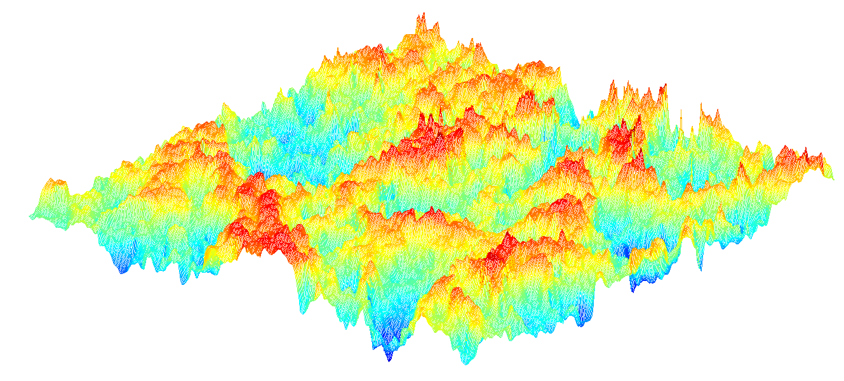
Figure 1: example of a rough surface.

In the present contribution, a computational method for the study of the frictional response of rough surfaces is proposed.

References

[1] Greenwood, J.A., Williamson, J.B.P., "The contact of nominally flat surfaces", Proc. R. Soc. Lond. A, 295, 300-319 (1966).
[2] Luan, B., Robbins, M.O., "The breakdown of continuum models for mechanical contacts", Nature, 435 929-932 (2005).

